High Level Design

**AIRPORT DATA ANALYSIS**

Nisha singh

Revision Number: 1.0

Last Date of Revision:26-01-2023



Document version Control

| Date issued | Version | Description | Author |
| --- | --- | --- | --- |
| 26/01/2023 | 1.0 | First version of complete HLD | Nisha singh |
|  |  |  |  |
|  |  |  |  |

**CONTENTS**

Document version control

Abstract

1. Introduction

1.1Why this High-Level Design document?

1.2 scope

2.General descriptions

2.1 product perspective & Problem statement

Airports are the nodal points of the aviation Network and a valuable source of information when all aeroplane movements, together with their associated passenger and cargo carried volumes, are systematically recorded. These data can be used for various types of analysis…………..

2.2 Tools used……..

3. Design Details

3.1 functional architecture

3.2 Optimisation

4. KPIs

4.1 KPIs ( key performance indicators)

5. Deployment

**Abstract**

Airports are the nodal points of the aviation network and a valuable source of information as all aeroplane movements, together with their associated passenger and cargo carried volumes, are systematically recorded. These data can be used for various types of analysis depending on the scope of the specific work. This chapter outlines an analysis performed for 28 Greek Island airports aiming to reveal key aspects of demand( seasonally and connectivity) and of supply (practical capacity of airports , characteristics of aeroplanes and air services). The spectrum of issues investigated include:

* The international passenger connectivity matrix between origin countries and Greek Islands, which allowed for the identification of tourist preferences as well as for the detection of missing links (lack of direct flights from certain countries to certain Islands). These missing links can be interpreted as market gaps or put differently, as market opportunities.
* the monthly, weekly, and daily aeroplane arrival patterns to their air side operating patterns as well as for the assessment of their practical capacity.
* the aeroplane types as well as their itineraries Which revealed that three- leg trips can be used in order to implement long haul International flights to Islands having short runways.

**1 Introduction**

**1.1**Why this High- Level Design Document ?

The purpose of the high level design document is to add the necessary detail to the current project description to represent a suitable model for coding. This document is also intended to help detect contradictions prior to coding and can be used as a reference manual for how the module interacts at a high level.

Airports are also a valuable source of information. as all aircraft movements together with their associated passengers and cargo carried volumes are systematically recorded. The scope is to present The variety of information that may be mind from an airport data set through common statistics but also through knowledge based mining techniques.

The HLD will:

* Present all the design aspect and define them in detail
* Describe the user interface being implemented
* Describe the hardware and software interfaces
* Describe the performance requirements
* include design features and the architecture of the project
* list and describe the non functional attributes like
* Security
* Reliability
* Maintainability
* Portability
* Reusability
* Application compatibility
* Resource utilisation
* Serviceability

1.2 Scope

The HLD documentation presents The structure of the system, such as the database architecture, application architecture(layers), application flow(Navigation), and technology architecture. The HLD use non technical to mildly-technical terms which should be understandable to the administrators of the system.

1. **General Descriptions**

**2.1** Product perspective & problem statement

A significant number of Public Works concern the issue of airport Runway optimization. Runway capacity is influenced by a range of actors such as: Runway layout and resulting dependencies, as correlation may exist between runways,e.g. Converging and diverging runways, intersecting runways, mixed mode, parallel runways And ground restrictions; regulation such as separation regulations such as wake turbulence, noise and emissions regulations; local conditions such as visibility and wind direction; fleet mix; Taxi and apron systems; and other factors including human factors system state and performance

Objective of the project is to perform data visualisation techniques to understand the insight of the data . This project aims to apply various business intelligence tools such as Tableau or Power Bi to get to a visual understanding of the data.

**2.2** Tools used

Business intelligence tools and libraries such as Numpy,Pandas,Excel,R,Tableau,Power BI are used to build the whole framework.



1. **Design Details**

**3.1** Functional Architecture

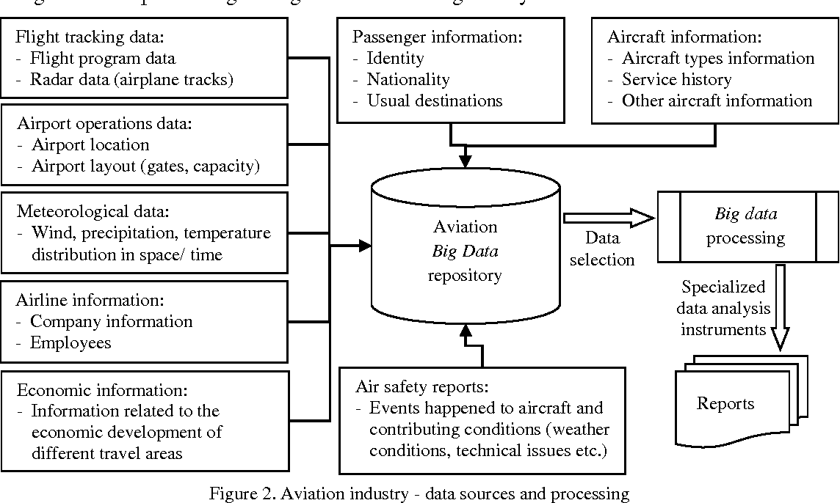

How BI Really Works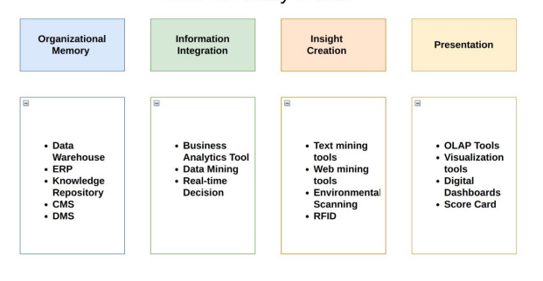

3.2 Optimization

**Your data strategy drives performance**

* Minimise the number of fields
* minimise the number of records
* Optimise extracts to Speed of future queries by materialising Calculations , removing columns and the use of accelerated views

**Reduce The marks(data points) in your view**

* Practice guided Analytics .There is no need to fit everything you plan to show in a single view. compiled related views and connected them with an action filter to travel from overview to highly- granular views at the speed of thought.
* Remove the unneeded dimensions from the detail self.
* Explore. Try displaying your data in different types of views.

**Limit your filters by number and type**

* Reduce the number of filters in use. Excessive filters on a view will create a more Complex query which takes longer to return results. double check your filters and remove any that are necessary.
* use and include filters. exclude filters load the entire domain of a dimension, while include filters do not. An include filter runs much faster than an exclude filter, especially for dimensions with many members.
* Use a continuous date filter. Continuous date filters( relative and range-of- date filters) can take advantage of the induction properties in your database and are faster than discrete filters.
* Use Boolean or numeric filters. Computers process integer and booleans(t/f) much faster than strings.
* Use parameters and Action filters.These reduce the query load (and work across data sources).

**Optimise and materialise your calculations**

* Perform calculations in the database
* Reduce the number of nested calculations.

Reduce the granularity of load table calculations in the view. the more granular the calculation, the longer it takes .

* LODs - Look at the number of unique dimension members in the calculation.
* table calculations - the more marks in the view, the longer it will take to calculate.
* Where possible, use MIN or MAX instead of AVG.AVG requires more processing than MIN or MAX. often rows will be duplicated and display the same result with MIN,MAX or AVG.
* Make groups with calculations. like include filters, calculated groups load only named members of the domain, whereas tableau’s Group function loads the entire domain.
* Use booleans or numeric calculations instead of string calculations. Computers can process integer and booleans(t/f) Much faster than strings.

Boolean>int>Float>Date>Datetime>string.

1. **KPIs**

Dashboards Will be implemented to display and indicate certain KPIs and relevant indicators for the disease.



As and when The system starts to capture the historical/ periodic data for a user, the dashboards will be included to display charts over time with progress on various indicators or factors.

4.1 KPIs (Key Performance Indicators)

Key indicators displaying a summary of the housing price and its relationship with different metrics.

1. Impact of number of flights.
2. impact of the most popular day.
3. influence of number of flights by day .
4. Influence of routes
5. Impact of distance
6. influence by map.

**5.Deployment.**

Prioritising data and Analytics couldn't come at a better time. your company ,No matter what size , is already collecting data and most likely analysing just a person of it to solve business problems, gain competitive advantages, and drive enterprise transformation. with the explosive growth of enterprise data, database technology and the high demand for analytical skills,Today's most effective it organisations have shifted their focus to enabling self service by deploying and operating tableau at scale, as well as organising, orchestration ,And unifying desperate source of data for business users and Experts I like to author and consume content. Tableau prioritizes choice in flexibility to fit to, rather than dictate, your enterprise architecture. tableau server and tableau online leverage your existing Technology investments and integrate into your IT infrastructure to provide or self service, modern analysis platform for your users. with on premises, cloud and hosted options, there is a version of tableau Too much you requirements.Below is a comparison of the three types.

TYPE PROS AND CONS

**Tableau server - on premises**

* Full control of hardware and software.
* infrastructure and data remain behind your firewall.
* Need dedicated administrators to manage hardware and software.
* Additional infrastructure needed to access off -network(mobile,external)

**Tableau server- Public cloud( laas )**

* Full control of software on managed hardware.
* puts infrastructure in same place as data**(**For migration to cloud**)**
* flexibility to spin up/down hardware as needed.
* need dedicated administrators to manage software.
* additional infrastructure needed to access off- network(mobile,external)

**Tableau online(SaaS)**

* Fully hosted solution( hardware, software upgrades)
* Fast to deploy
* Easy for external audience to access
* Single site in multi -tenant environment
* cubes are not supported
* no guest account access

Depending on your organisational roles and responsibilities.Tableau server should be installed by a systems administrator and the designated Tableau server administrator in coordination with the appropriate IT roles. For Tableau online, you will integrate with your existing Technology and configure the site settings. The Data & Analytics Survey completed by Business teams, identifies and Prioritizes data use cases, audience size, And users. you will use the information collected in both services to plan your deployment strategy. including sizing installation and configuration of your tableau server or integration and configuration of Tableau online. in addition to installing Tableau server or configuring tableau online. administrators will also need to plan For the client software installation of tableau prep builder, Tableau Desktop, Tableau bridge for Tableau online where applicable.